- Purpose
  - The purpose of this document is to describe the procedure for assembling a Crewman high speed burnisher.
- Scope
  - This SOP applies to all equipment assembly team members. The process applies to the following machine ID’s:
E083015EQM0600BE1200 – Crewman 1600 RPM Cord-Electric Burnisher
E083015EQM0607BE1200 – Crewman 1600 RPM Cord-Electric Burnisher-Canada
E083016EQM0600BE1200 – Crewman 2000 RPM Cord-Electric Burnisher
E083016EQM0600BE1200 – Crewman 2000 RPM Cord-Electric Burnisher-Canada
- Responsibilities
  - The operations manager/supervisor is responsible for enforcing this SOP.
- Materials
  - The proper materials needed for this process are listed on the machine work order.
  - Hand/Power Tools
- Definitions

- Procedure
  - Start by placing a high speed base (83138) upside down on the table. Inspect the base inside of the circled area and esure that it is flat. Any bowing will misalign the pulley to the motor and cause the belt to slip off.
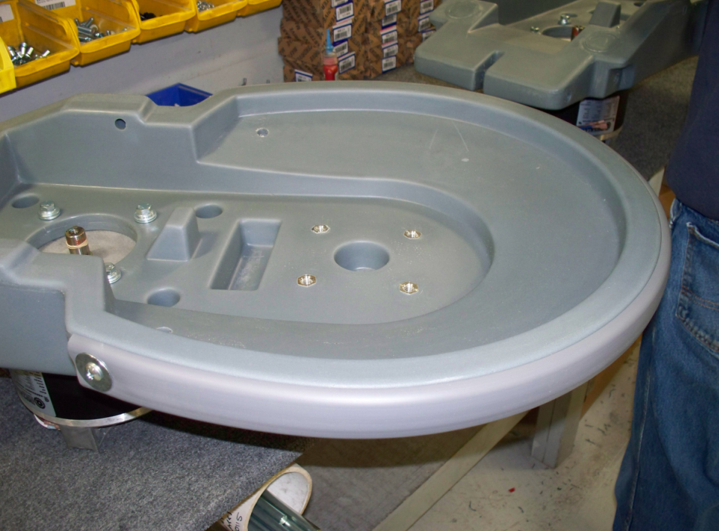
  - Once inspected, place the base into the drill fixture. Using the shorter ½” diameter drill bit, drill out the front wheel axle holes on both side of the base.
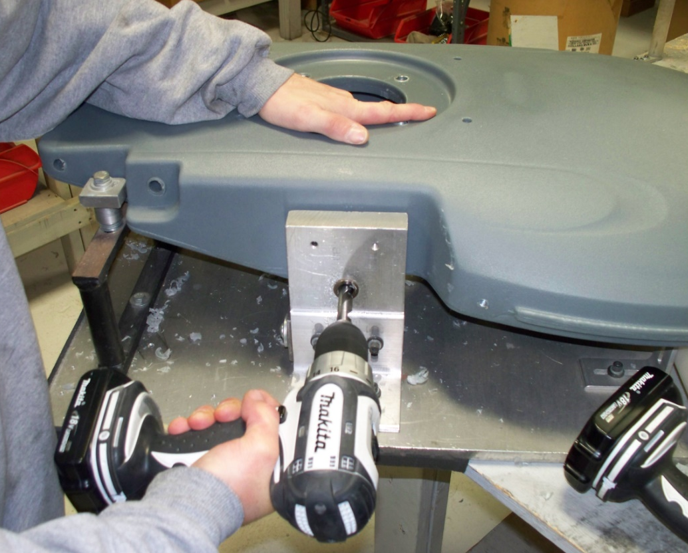

  - Next, use the long ½” diameter drill bit to drill out the hole for the rear wheel axle and the handle axle. Drill these through the entire base. Be sure to drill the hole straight so that the axle functions properly.
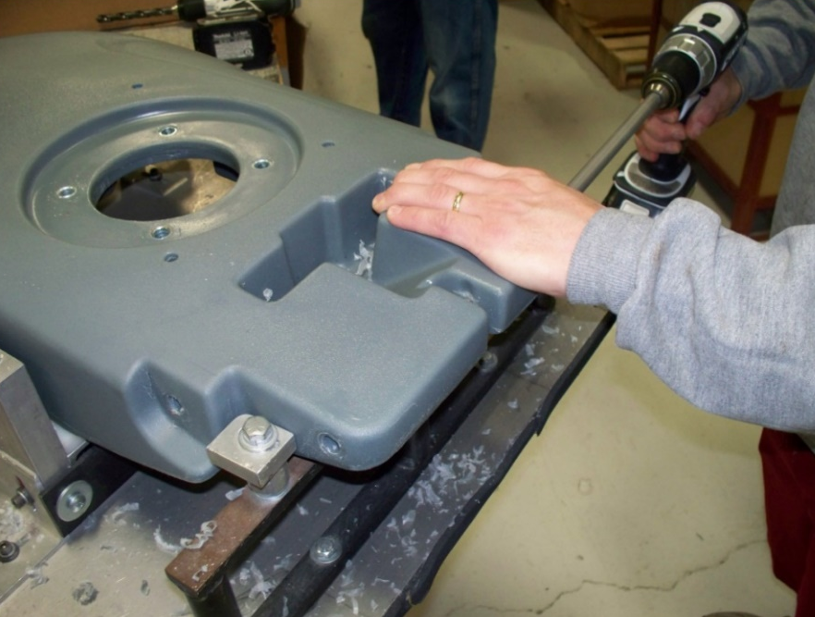
  - Lay a motor (84999) flat on the assembly table with the spindle pointing up vertically. Place the drilled out base on top of the motor so that the 4 motor bolt holes line up. Orient the motor so that the cord points towards the back side of the base. Attach the base to the motor with 4 bolts (83629), lock washers (81066), and 4 flat washers (81062). Use blue locktite on the bolts.
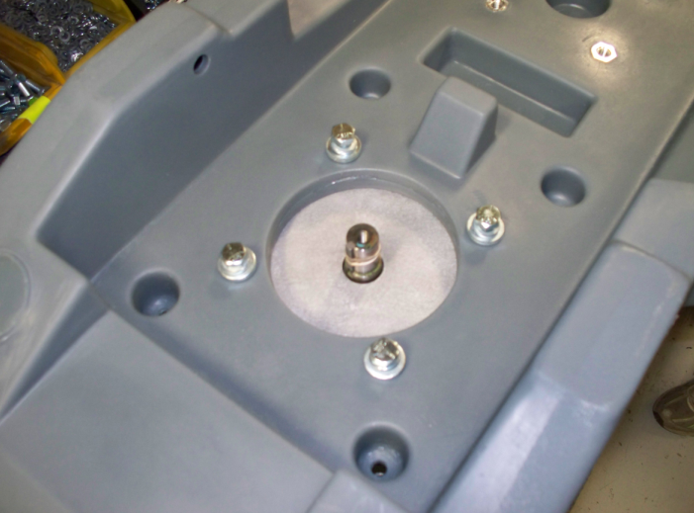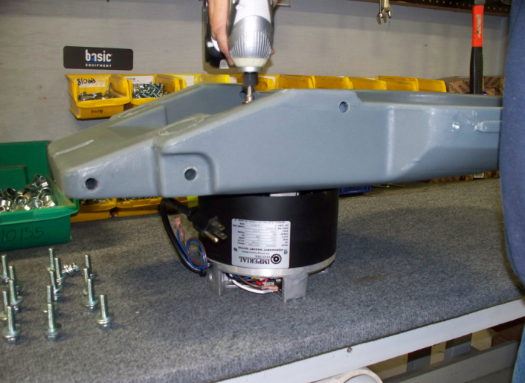
Cord Orientation

  - Install the bumper (83141). Attach each end of the bumper using a screw (83425) and a washer (81068). If there is plastic in the holes they will need drilled and re-tapped. Fasten each end of the bumper at the proper orientation then work your way around the front of the base stretched in bumper until it is properly located.
Bumper
Screw and washer (both sides)

  - Take a Pulley Mount Bracket (83150) and thread a bolt (83629) and a nut (81069) into the bent flange. These will be used to tension the belt. Lay the bracket so that it lines up with the 4 holes in the base. Use 4 bolts (81080), lock washers (81066), and flat washers (81062) to attach the plate to the base. Do not fully tighten the bolts yet as the belt tension needs to be set first.
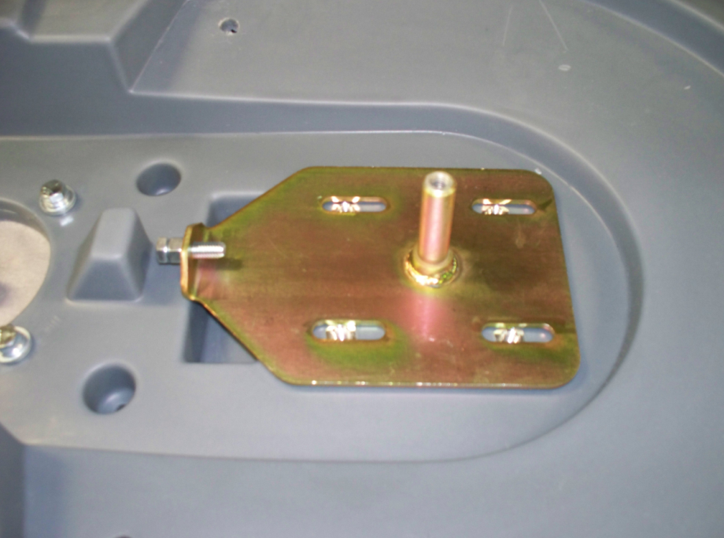
Use for Tensioning

  - Remove the key from the motor shaft and slide a spacer (83787) onto the shaft. This will set the height of the pulley. Replace the key into the keyway. Select the correct motor pulley for the speed of machine being built. For the 1600 RPM model, use pulley 83478 and for the 2000 RPM model, use pulley 81276. Remove the set screws from the pulley and throw them away. Slide it onto the motor shaft using the key provided on the motor. Fasten the pulley to the shaft using a bolt (81072), a lock washer (81067), and a flat washer (81062). Be sure to use blue loctite on the bolt.
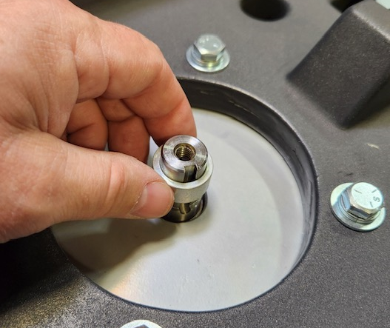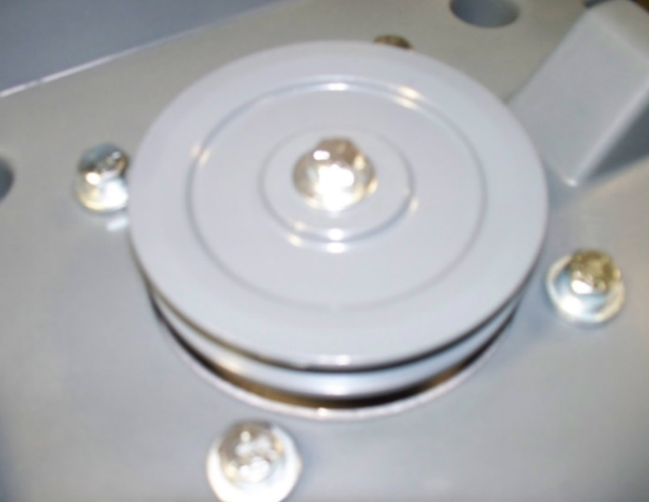
  - Now assemble the pad drive pulley. This requires a pulley (83376), 2 bearings (83310), and a bearing spacer (83377). First, press a bearing into one side of the pulley using the hydraulic press. Be sure the bearing is as centered as possible before pressing. Press until the pressure gage reads 4 bar.
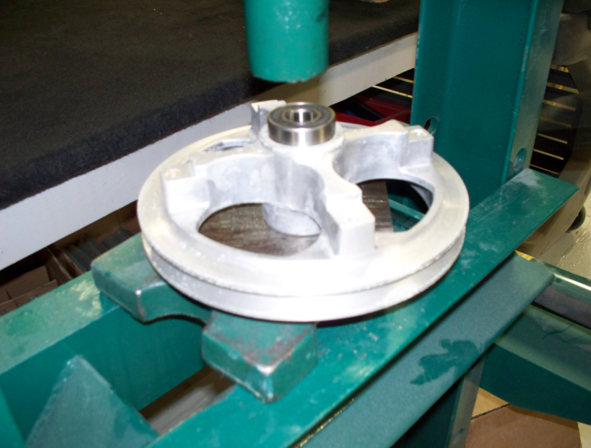

  - Flip the pulley over and put the bearing spacer into the hole. Next, place the second bearing centered in the bore. Press it into place until the same pressure is reached as for the other bearing.
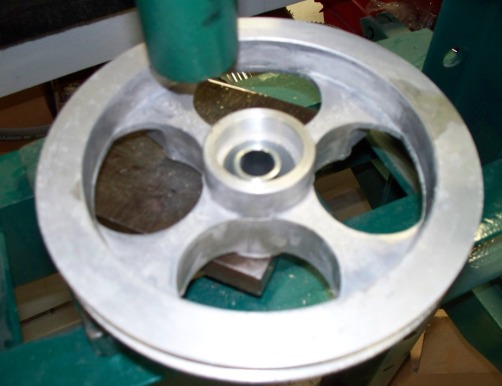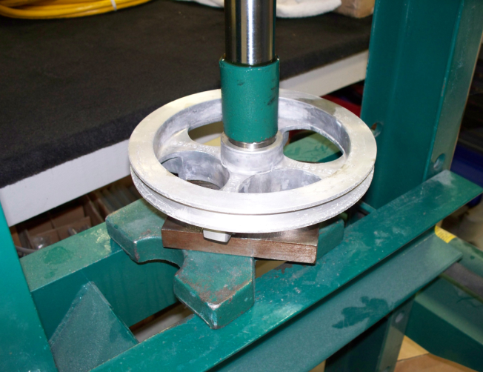
Bearing Spacer

  - Take the assembled pulley and slide it onto the shaft of the pulley mount bracket. Note the orientation of the pulley in the photo below. Use 1 bolt (85396), lock washer (81066), and flat washer (81062) to attach the pulley to the shaft. Be sure to use blue locktite on the bolt.
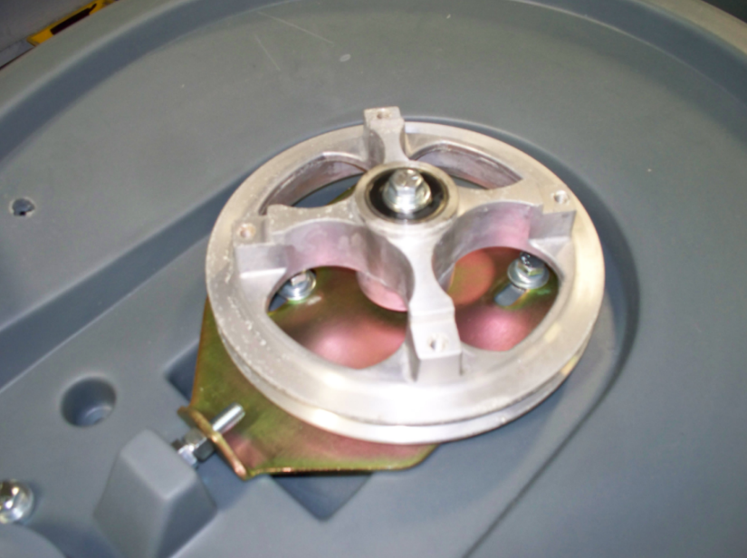
Note the pulley orientation

  - Take the proper belt and install it on the two pulleys. For a 1600 RPM machine, use 83140 and for a 2000 RPM machine, use 83149. Once the belt is installed, thread the bolt on the pulley mount bracket out until the belt is at the proper tension. Once the desired tension is reached, tighten the nut against the plate to fix the location. The last step is to fully tighten the 4 bolts that hold the pulley mount bracket using an impact.
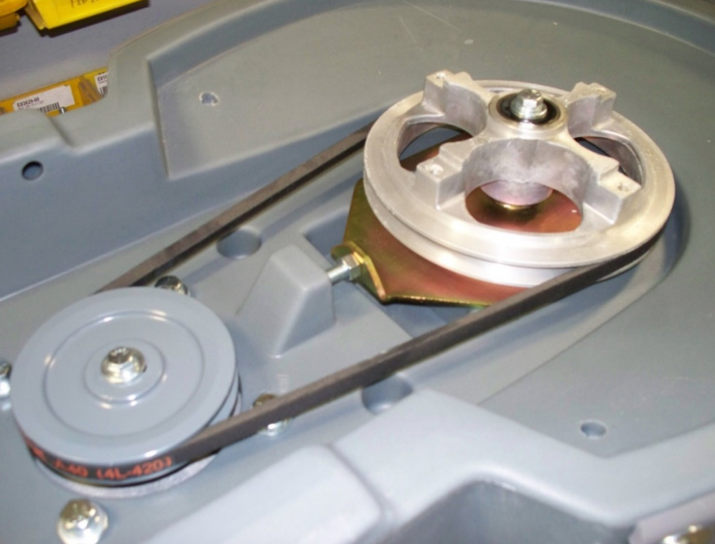
Tighten bracket bolts
Use bolt and nut to tension belt
  - Attach the pad driver assembly (83148) to the pulley using 4 screws (83190). Taking the center lock off helps to get access to the screws with a drill.
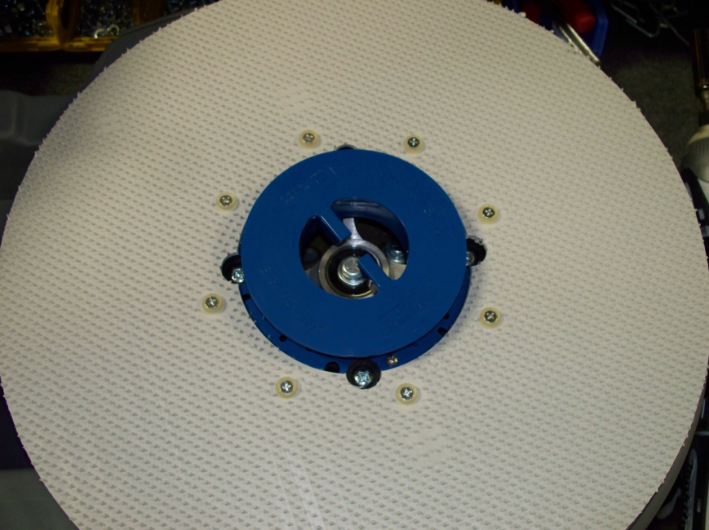

  - Install the front wheel axle (83651) using a rubber mallet. Center the shaft as best as possible.
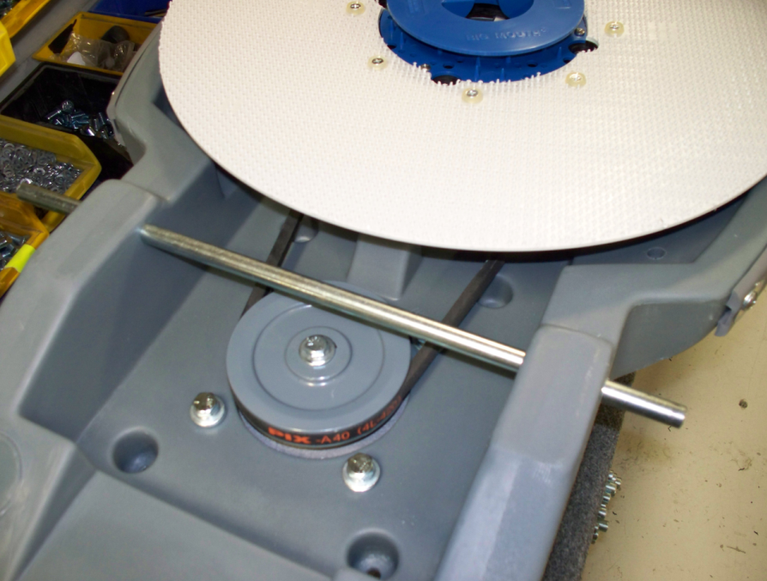

  - Next, install the rear wheel axle (83379) just under halfway using a rubber mallet. As the shaft starts to come through the center cutout, place the handle bracket (83136) with a nylon washer (83145) on each side into the cutout so that the shaft will pass through them. Continue pounding the shaft all the way through. Center it as best as possible.
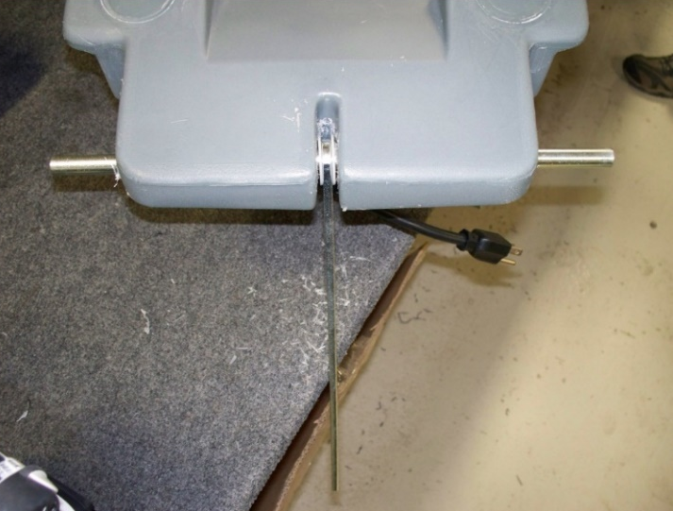
Washer-Bracket-Washer

  - On each end of the 2 shafts (4 locations total) that were just installed, put a spring washer (83269) and nylon washer (83145) on. The spring washer is to be on the inside against the machine base while the nylon washer is to be on the outside against the wheel. On the front shaft, place a 5” wheel (81124) on each end. On the rear shaft, place a 4” wheel (81125) on each end. Finally, pound the axle caps (83143) onto each of the 4 shaft ends using the tool provided.
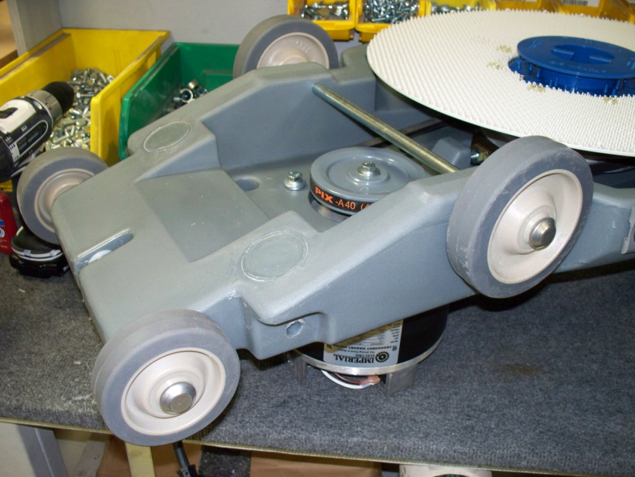
Spring and Nylon washer are hidden behind the wheels in the picture
Axle caps 4 places
4” wheel
5” wheel
  - Wrap the wheels with plastic to keep them clean.
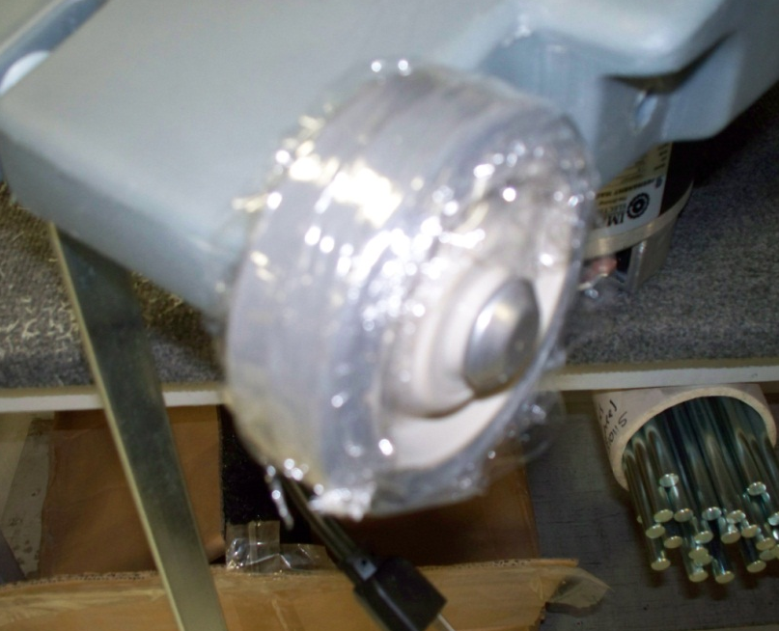

  - Flip the assembly over. Press 4 plastic plugs (81071) into the unused holes in the base around the motor.
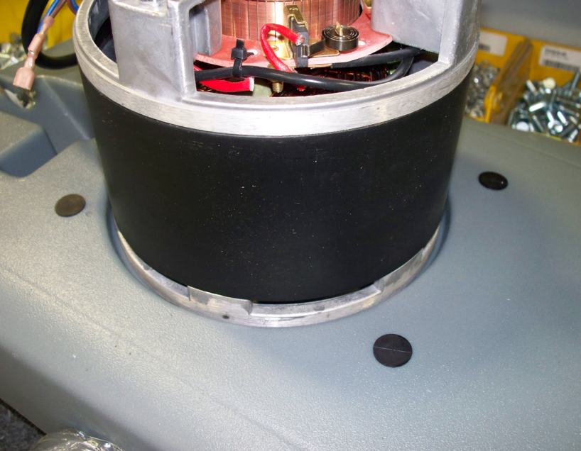
4 places

  - Attach the motor cover (81141) to the top of the motor using 3 screws (88696). If the screws do not easily thread in, you may need to drill out the motor holes. Do not force the screws in. If the machine is to be certified for sales into Canada (E083015EQM0607BE1200 and E083016EQM0607BE1200) apply some flame proof paint onto the inside surface of the motor cover. The paint should not be visible once the cover is installed.
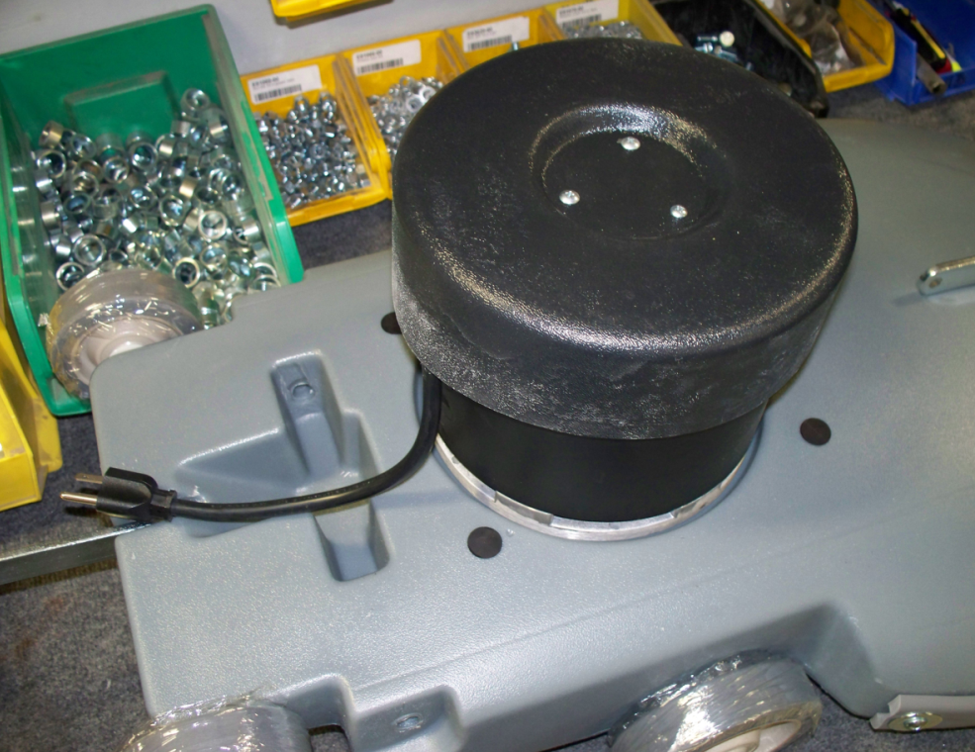

  - On the front of the motor, place a Betco Equipment sticker (83773).
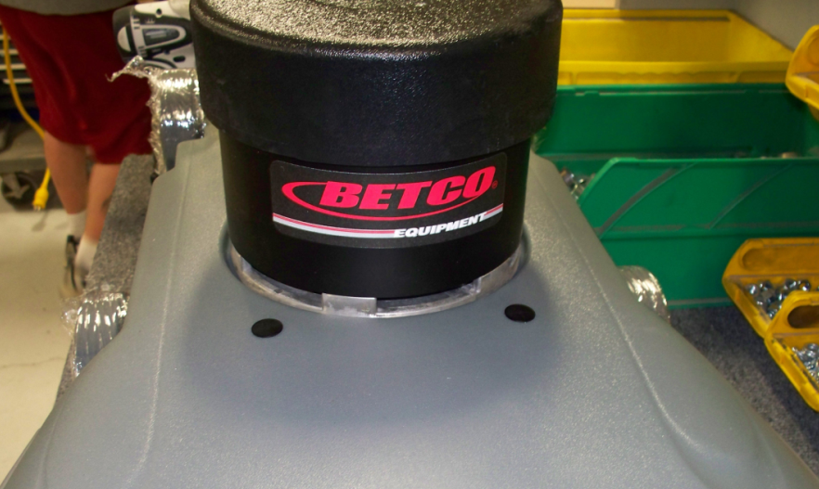

  - Assemble the handle for the machine. For assembly instructions, refer to SOP EQ 022.
  - Place the T-attachment end of the handle into the groove in the base. Install the shaft (83452) through the base and through the T-attachment. This will hold the handle in place. Once the handle is installed and centered. Install an axle cap (83143) on each end of the shaft.

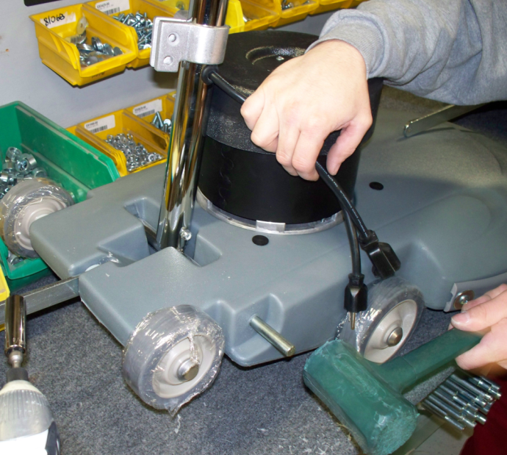

  - Secure the strut to the cord wrap using a shoulder bolt (81077) and a nut (81063).

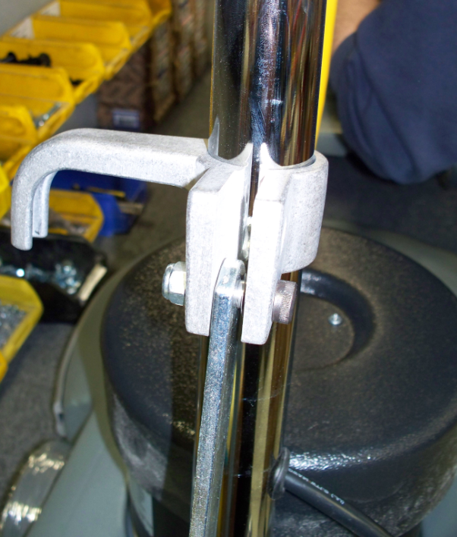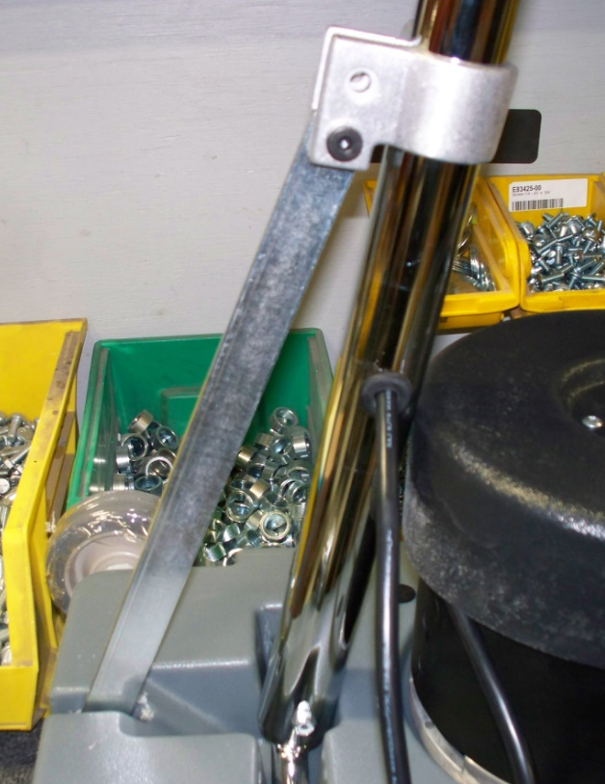
Nut
Bolt
  - Assemble the cam handle using the following components: 1 cam handle (83133), 1 oval washer (83135), 3 nylon washers (83145), and 1 nut (81063). The oval washer presses onto the similar profile on the stem of the cam handle. Note the order of the parts below.

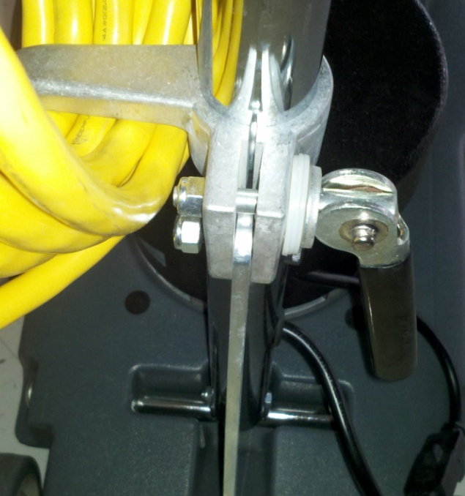
Nut
Cam Handle
Oval Washer
Nylon Washers

  - Tighten the nut enough so that the cord hook slides easily up and down the handle shaft when the cam is released and holds the base and handle tight when the cam is engaged.
  - Plug the cord from the motor into the cord coming from the handle.

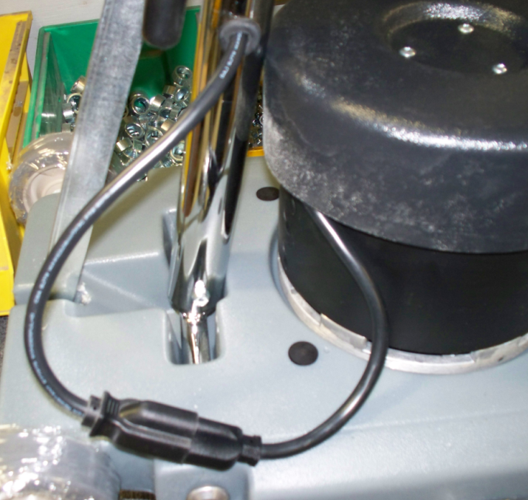

  - Put the the appropriate decal on the front of the handle to designate the type of machine it is. Use 83735 for a Crewman 2000 and use 83730 for a Crewman 1600.

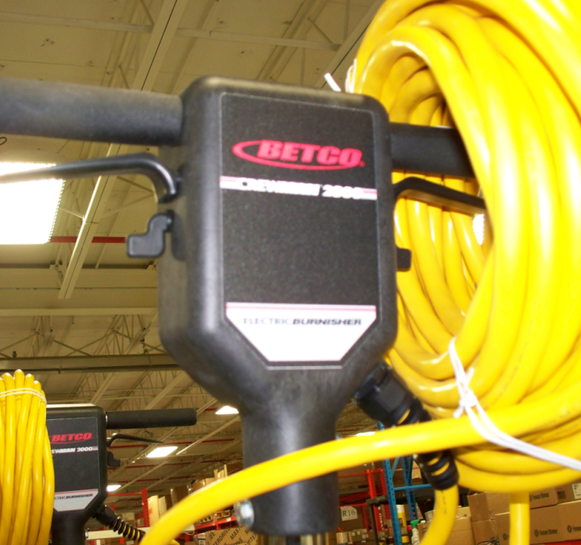

  - If the machine is to be certified for sales into Canada (E083015EQM0607BE1200 and E083016EQM0607BE1200) place a Canadian electrical warning decal onto the back side of the motor cover facing the operator.
  - The machine assembly is now complete and ready for testing.

- References (optional section as needed)

- Training Guide

Functional Training Groups Requiring Training
Equipment Group

- SOP Change Control

Date of Change | Reason for Change
Rev 01 - 11/22/2013 | This is the first version of the S.O.P. hence there are no revisions to this document.
Rev 02 - 12/7/2017 | Updated with hardware changes and added Responsibilities section.
Rev 03 - 5/15/2019 | Changed the number of 83145 on the cam lock handle from 1 to 3. jb
Rev 04 - 3/14/2025 | Updated format and removed work center notes

Approvals

Submitter/AuthorApproval: 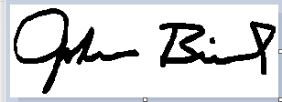 Date:______5/15/2019________________

Management Approval: Date:________5/15/2019_____________

QAU Approval:  Date:_____5/15/2019_________________

